Please discuss the advantages and disadvantages (e.g. in terms of oxygen demand, sludge production, etc.) of using treatment concepts a-e for scenario A and B

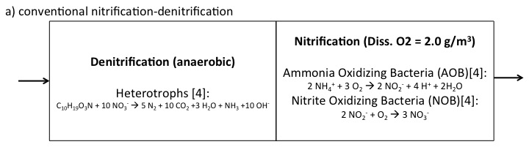

|  |  |
| --- | --- |
| **Pros** | **Cons** |
|  | High Sludge Production |
|  | High Oxygen Demand |
| Simultaneous C Removal | Required High C/N Ratio |
|  | High Square Footage Consumption |

|  |  |
| --- | --- |
| **Pros (assuming CANON)** | **Cons** |
| Lowest Sludge Production |  |
| Low Oxygen Demand |  |
|  | Poor Removal Efficiency |
|  | Very Poor Removal at Low Temp |
| Low C/N Ratio OK | May need extra tank to remove C |
| Low Square Footage  Consumption |  |

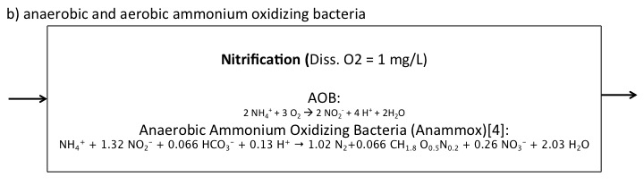

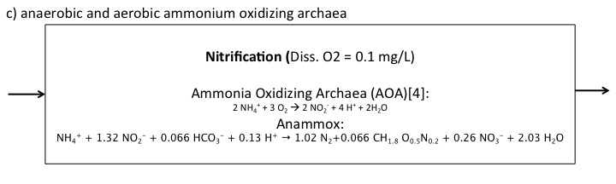

|  |  |
| --- | --- |
| **Pros (assuming CANON)** | **Cons** |
|  | Unproven in lab or full scale |
| Lowest Sludge Production |  |
| Lowest Oxygen Demand |  |
| Theoretically excellent Removal |  |
| Low C/N Ratio OK | May need extra tank to remove C |
| Low Square Footage Consumption |  |

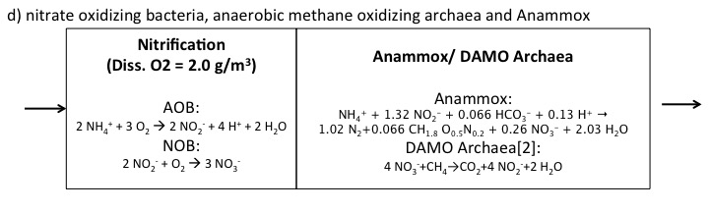

|  |  |
| --- | --- |
| **Pros (assuming CANON)** | **Cons** |
|  | Unproven in lab or full scale |
| Low Sludge Production |  |
|  | High Oxygen Demand |
| Poor conversion in nitrification OK |  |
| Low affinities of anaerobes mean excellent removal possible |  |
| Low C/N Ratio OK |  |
|  | Requires a specific form of COD (CH4) |
|  | Slow growing organisms mean long SRTs mean large tanks req’d |

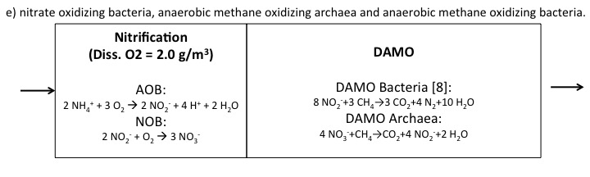

|  |  |
| --- | --- |
| **Pros (assuming CANON)** | **Cons** |
|  | Unproven in lab or full scale |
| Low Sludge Production |  |
|  | High Oxygen Demand |
| Poor conversion in nitrification OK |  |
| Low affinities of anaerobes mean excellent removal possible |  |
| Low C/N Ratio OK |  |
|  | Requires a specific form of COD (CH4) |
|  | Slow growing organisms mean long SRTs mean large tanks req’d |

Scenario A: Centrate Treatment

|  |  |  |  |  |  |  |
| --- | --- | --- | --- | --- | --- | --- |
| **Scenario A** | | | | | | |
| **Parameter** | Units | a) | b) | c) | d) | e) |
| COD Rem Eff. | wt/wt% | 0% | 0% | 0% | 0% | 0% |
| Sludge Production | gVSS/gN | 297 | 41.0 | 41.0 | 80.2 | 65.2 |
| Oxygen Consumption | gO2/gN | 914 | 343 | 343 | 914 | 914 |
| Alkalinity Consumed | % gCaCO3 | 50% | 47% | 47% | 47% | 50% |
| Min SRT | days | 1.8 | 15 | 15 | 31 | 31 |
| COD Addition Req'd | gCOD/gN | 1141 | 0 | 0.0 | 14.3 | 43.4 |

Centrate is characterized by high temperature, low flowrates, high N concentration, and low C concentration. Additionally, low conversion rates are acceptable, since it will ultimately be diluted by the mainstream flow.

Given the low C/N ratio and acceptable low conversion efficiencies, **concept B or C (CANON system) would be preferable for this scenario.** Because only half of influent N needs to be only partially oxidized from ammonium to nitrite, oxygen demand is very low. That will save a lot of operational cost that aeration typically makes up 2/3 of a WWTP’s energy cost.

Scenario B: Mainstream Treatment

|  |  |  |  |  |  |  |
| --- | --- | --- | --- | --- | --- | --- |
| **Scenario B** | | | | | | |
| **Parameter** | Units | a) | b) | c) | d) | e) |
| COD Req'd | gCOD/gN | 2.9 | 0% | 0% | 0.1 | 0.2 |
| Sludge Production | gVSS/gN | 29 | 4.0 | 4.0 | 7.9 | 6.4 |
| Oxygen Consumption | gO2/gN | 90 | 34 | 34 | 90 | 90 |
| Alkalinity Consumed | % gCaCO3 | 35% | 33% | 33% | 33% | 35% |
| Min SRT | days | 6.7 | 33 | 18 | 42 | 42 |

Mainstream wastewater is characterized by low temperature, high flowrates, low N concentration, and high C concentration. Conversion rates of N must be high, ideally so that effluent N is 0.5 – 3 mgN/L.

* Concept A is typically used, but is expensive.
* Because conversion rates are critical here, concept B will be unacceptable.
* If there is some kind of mainline C removal already in place, and the plant is trying to supplement with some additional nutrient removal, concept C is ideal as it has both low operational and construction costs associated.
* Concept D plus some kind of mainline COD removal has the advantage of allowing for poor control in the nitrification compartment. If a mix of nitrite + nitrate is fed to the anaerobic compartment, that is fine. In addition, a recycle stream could be implemented to convert all of the NO3- produced by anammox. However, these are all very slow growing organisms, so a SRT would be required for efficient removal.
* Concept E is odd, because from a theoretical standpoint, the DAMO Archaea doesn’t really appear to be required. However, again you could allow for poor conversion in the aerobic compartment. But also, we still run into the issue of having very slow growing organisms and designing a large tank to account for the long SRTs required.

Additional Suggestion

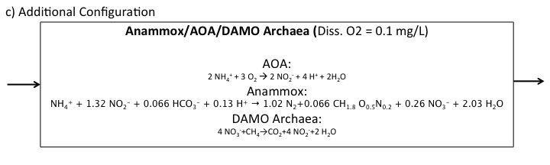

I propose implementing a combination of scenarios C & D for mainstream N removal. C removal could be accomplished via an upfront mainstream digester (not pictured). Methane could be collected from the offgas from that digester, and the effluent from that digester would be saturated w/ methane. The dissolved methane alone is more than enough to supple DAMO archaea with excess methane. Meanwhile, granular AOA/Anammox could be removing ammonium. Any nitrate produced via anammox could be converted back to nitrite via DAMO archaea, which could also be implemented into the granular biofilm.

This set-up has the potential for very near 100% N removal at low temperature and low C/N ratios with significantly reduced sludge production and oxygen demand.